Neurobiobank München
Reference Centre for Neurodegenerative Diseases

Direction:
Prof. Dr. med. Jochen Herms
Centre for Neuropathology and Prion Research
Prof. Dr. med. Peter Falkai
Department for Psychiatry and Psychotherapy
Centre for Neuropathology and Prion Research
Feodor-Lynen-Str. 23
81377 Munich
Tel.: 0049 89 / 2180-78345
Fax: 0049 89 / 2180-78037
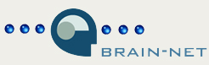
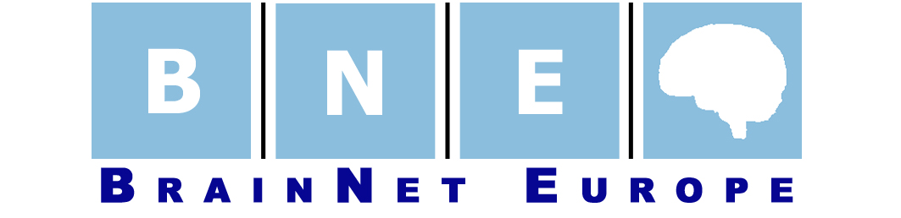

Tissue request
Name:

Institute:

Address:

Phone:

Telefax:

Email:

Project title:

Summary of the project (a maximum of two pages):

By which funds is the project supported?

Have you obtained local research ethical committee approval for your project?

Tissue samples details:

Number of tissue samples from patients:

Definition of the patient (e.g. "Alzheimer patient with CERAD C and Braak & Braak stage 5-6"):

Number of tissue samples from control persons:

Definition of the control person (e.g. "age 50-70", "no dementia"):

Required brain regions (exact anatomical description):

Tissue treatment (formalin-fixed, frozen etc.):

Quantity (in cm³):

Maximum post-mortal time:

Have you already performed pilot studies / animal experiments for this project?

Planned duration of the project:

Do you have a VAT ID (trade ID)
VAT-ID-Number:

Please send the filled form as email attachment to:

Brain-Net Office: Dr. Otto Windl
nbm@med.uni-muenchen.de

Postal address: Neurobiobank Munich
Centre for Neuropathology and Prion Research
Ludwig-Maximilians-University Munich
Feodor-Lynen-Str. 23
81377 Munich
Germany
Tel.: 0049 89 / 2180-78133
Fax: 0049 89 / 2180-78037

Datum:

